Task-based Classes, Objects, and Functions

Task Creation Tools : Used in constructing and initializing the *Task* object and its variables.

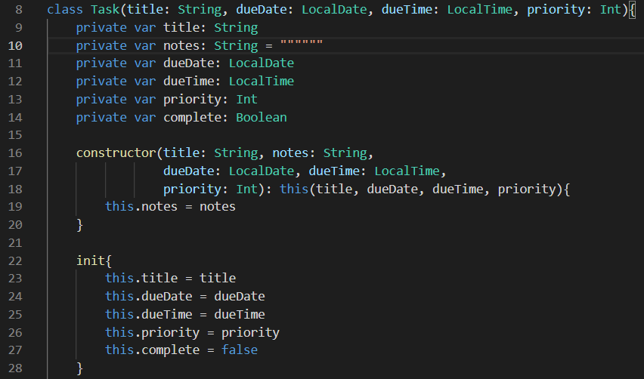

Get Functions : Returns Variable Data Set Functions: Inputs Variable Data

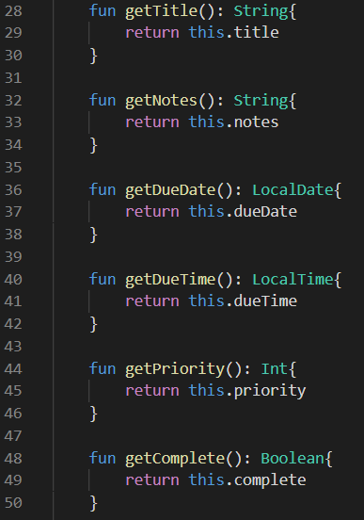 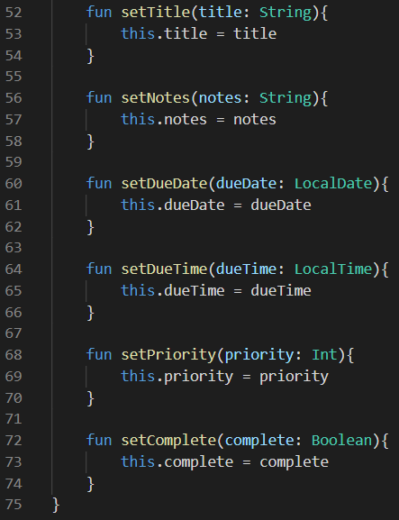

Task List Modifier : Used add/remove *Tasks* in the *Task List*.

